*Transport Management system*

Test report

Version *<1.0>*

*<05/04/2016>*

VERSION HISTORY

|  |  |  |
| --- | --- | --- |
| **Version #** | **Implemented By** | **Revision Date** |
| 1.0 | *Team 1* | *<05/04/2016>* |
|  |  |  |
|  |  |  |
|  |  |  |

**Table of Contents**

1.0 Introduction 4

1.1 Purpose 4

2.0 Test PLAN 4

3.0 Test Assessment 4

4.0 Test Results 4

4.1 Unit TESTING 5

4.2 Integration Testing 5

4.3 System Testing 9

4.4 User Acceptance Testing 10

4.5 Regression Testing 11

4.6 Performance Testing 11

4.7 UI Testing 13

4.8 Issues with SRS 14

5.0 Variances 14

6.0 Test Instances 14

6.1 Resolved Test Incidents 14

6.2 Unresolved Test Incidents 14

7.0 Recommendations 15

APPENDIX A: REFERENCES 15

APPENDIX B: KEY TERMS 16

# 1.0 Introduction

## 1.1 Purpose

This *Transport Management System* Test Report provides a summary of the results of test performed as outlined within this document.

# 2.0 Test PLAN

Unit testing is done to identify defects in particular modules such as classes and functions.

Integration testing will be done to ensure module interaction is smooth.

This will be followed by system testing to ensure that there are no differences in the requirements specification and the implemented software. It is also a check against high level design document.

User Interface (UI) testing will be done to ensure that UI design principles are not violated.

Performance testing (Load testing) to determine the response towards high site traffic levels.

Defects in the SRS document are reported.

# 3.0 Test Assessment

A significant number of bugs have been observed in the code. The effectiveness of the tests were very high. The number of failed tests constituted a high proportion of the total tests conducted.

# 4.0 Test Results

Number of tests conducted: 40

Number of tests failed: 37

Number of assertions made: 28

Number of bugs detected: 35

## Unit TESTING

The table below summarizes the test cases employed for unit testing and the test results obtained for each test case:

|  |  |  |  |  |  |  |
| --- | --- | --- | --- | --- | --- | --- |
| Test Case ID | Date Tested | Module | Tester | Summary | Closed prior to Production Release? | Comments |
| UN001 | 04/04/2016 | Generate Invoice | Archil | The value of date have been hardcoded. To edit them the admin has to change them directly in the code |  | NA |
| UN002 | 04/04/2016 | Generate Schedule | Archil | No check on the number of buses available. Just sees the number of students and the capacity of the buses |  | NA |
| UN003 | 04/04/2016 | Generate Schedule | Archil | The schedule of the buses for Saturday and Sunday have been hardcoded. To edit them the admin has to change them directly in the code |  | NA |

## Integration Testing

The table below summarizes the test cases employed for integration testing and the test results obtained for each test case:

|  |  |  |  |  |  |  |  |  |
| --- | --- | --- | --- | --- | --- | --- | --- | --- |
| Test Case ID | Date Tested | Description | Tester | Pass/Fail | Severity | Summary | Closed prior to Production Release? | Comments |
| IN001 | 29/03/2016 | Assert that attempt to login as student with valid credentials succeeds | Mohit | Pass | NA | NA |  | NA |
| IN002 | 29/03/2016 | Assert that attempt to login as student with invalid credentials fails | Mohit | Pass | NA | NA |  | NA |
| IN003 | 29/03/2016 | Assert that attempt to change password renders change password route | Mohit | Fail | Moderate | Change password feature does not exist in the application. However, a stub link is present on the login page. |  | The stub link must be removed, as the SRS does not mention change password feature. |
| IN004 | 29/03/2016 | Assert that only logged in students are allowed to access place request route | Mohit | Fail | High | Any user who is logged in, irrespective of the user type is able to access the place request route, which should be available only to student users. |  | User type must be properly added to the session. |
| IN005 | 29/03/2016 | Assert that only valid data can be submitted through place request feature for students | Mohit | Fail | Moderate | 1) Dates before current date are accepted.  2) End time values later than start time are accepted and vice versa. 3) The number of students can be negative. |  | Data validation needs to be added. |
| IN006 | 29/03/2016 | Assert that request from student is displayed on admin's notification page | Mohit | Pass | NA | NA |  | NA |
| IN007 | 29/03/2016 | Assert that multiple requests can be sent from a student | Mohit | Fail | Low | Only one request per student is permitted |  | NA |
| IN008 | 29/03/2016 | Assert that admin in able to view notifications as submitted by student | Mohit | Fail | High | 1) ID field is empty. 2) Date is displayed as 0000-00-00 |  | The vales are stored wrongly in the database as well. |
| IN009 | 29/03/2016 | Assert that admin pages are accessible only after logging in as admin | Mohit | Fail | High | 1) Admin home page is accessible to any visitor on site, even without login 2) Check availability page is accessible to any visitor on site, even without login |  | User type must be properly added to the session. |
| IN010 | 29/03/2016 | Assert that student user cannot access admin pages | Annuay | Fail | High | NA |  | High security breach |
| IN011 | 29/03/2016 | Assert that check availability feature of admin returns acceptable values | Annuay | Fail | High | After changing the bus settings the schedule returns negative values for number of buses available at specific times. The number of buses at times exceed the total availability of buses. |  | Logic behind scheduling buses must be rechecked. |
| IN012 | 29/03/2016 | Assert that data is validated in change settings feature | Annuay | Fail | Low | Any values are currently accepted |  | NA |
| IN013 | 29/03/2016 | Assert that all values displayed under extra buses schedule feature are valid | Annuay | Fail | Low | Null values in date field |  | NA |
| IN014 | 29/03/2016 | Assert that invoice is generated with correct number of buses | Annuay | Fail | Moderate | The total number of buses is incorrect. |  | NA |
| IN015 | 29/03/2016 | Assert that the number of extra buses match in invoice generation and extra bus schedule | Annuay | Fail | Moderate | The numbers do not match |  | NA |
| IN016 | 29/03/2016 | Assert that generated schedule is in accordance with the availability of buses | Annuay | Fail | Moderate | Buses are scheduled even when no buses are available. |  | NA |
| IN017 | 29/03/2016 | Assert that logout terminates the session | Annuay | Pass |  | NA |  | NA |

## 4.3 System Testing

The table below summarizes the results of system testing:

|  |  |  |  |  |  |  |  |  |
| --- | --- | --- | --- | --- | --- | --- | --- | --- |
| Test Case ID | Date Tested | Description | Tester | Pass/Fail | Severity | Summary | Closed prior to Production Release? | Comments |
| ST001 | 30/03/2016 | Copy of bus schedule can be downloaded | Mohit |  | Moderate | No such Feature |  | NA |
| ST002 | 30/03/2016 | There are two different kinds of user accounts | Mohit |  | High | Although the distinction between student and admin users exist in database, there is no check while authorizing users to access pages. |  | Admin and student can see each other's sections. |
| ST003 | 30/03/2016 | Software calculates number of extra buses requires | Mohit |  | Low | No such feature |  | NA |
| ST004 | 30/03/2016 | Generate schedule as per sequence diagram asks for user input before generating schedule, but is not implemented the same way | Mohit |  | Low | NA |  | NA |
| ST005 | 30/03/2016 | Functional Req.: Use case 4: Approve Request: Availability of buses is not  updated | Angad |  | Moderate | NA |  | NA |
| ST006 | 30/03/2016 | Functional Req.: Use case 7: Schedule Generation: Contrary to what is stated in step 2, there is no provision to fill in the academic schedule | Angad |  | Moderate | NA |  | NA |
| ST007 | 30/03/2016 | Functional Req.: Use case 8: Invoice Generation: Invoice can be generates anytime | Angad |  | Low | SRS states that invoice is generated at the end of every month |  | NA |
| ST008 | 30/03/2016 | Change Settings feature of admin is not part of functional requirements | Angad |  | Low | NA |  | NA |

## User Acceptance Testing

The table below summarizes the test cases employed for user acceptance testing and the test results obtained for each test case:

|  |  |  |  |  |  |  |  |
| --- | --- | --- | --- | --- | --- | --- | --- |
| Test Case ID | Date Tested | Tester | Pass/Fail | Severity of Defect [Low/ Medium/ High] | Summary of Defect | Closed prior to Production Release? *[This column will be filled by the dev team.]* | Comments |
|  |  |  |  |  |  | <Yes> or <No> |  |

## Regression Testing

Regression Testing is a multiple iterations of unit, iterations and system testing.

## Performance Testing

**Load Testing for Place_request Page (Done By Angad Sabherwal)**

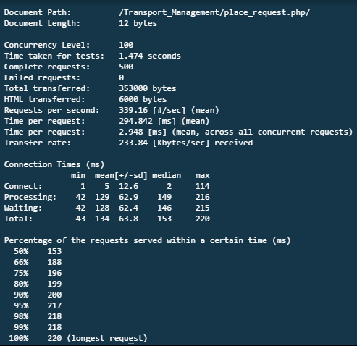

**Load Testing for Login Page (Angad Sabherwal)**

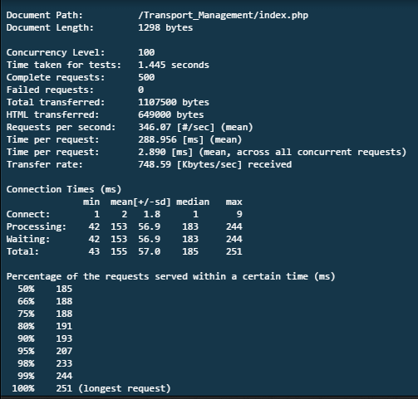

## UI Testing

The table below summarizes the test cases employed for UI testing and the test results obtained for each test case:

|  |  |  |  |  |  |  |
| --- | --- | --- | --- | --- | --- | --- |
| Test Case ID | Date Tested | Tester | Page Name | Description | Severity | Closed prior to Production Release? |
| IN001 | 02/04/2016 | Archil | Login | Echo statements used for the purpose of testing are displayed along with error message displayed at unsuccessful login attempt. | Low |  |
| IN002 | 02/04/2016 | Archil | Login | Improper error message format | Low |  |
| IN003 | 02/04/2016 | Archil | Place Request | The button 'Notification' is clubbed along with the form, wrongly suggesting the user that he must fill the same to see his notifications. | Moderate |  |
| IN004 | 02/04/2016 | Archil | Place Request | Notifications get cluttered on top of the page, and there is no system in place to remove them. | Moderate |  |
| IN005 | 02/04/2016 | Archil | Place Request | The page does not convey its purpose explicitly to the student user. | Moderate |  |
| IN006 | 02/04/2016 | Archil | Notify Admin | In case of no notifications, a blank page is displayed. | Low |  |
| IN007 | 02/04/2016 | Archil | Check Availability and Extra Bus Schedule | Time display format is improper. Times are not arranged in a proper order. | Low |  |
| IN008 | 02/04/2016 | Archil | Admin and Student homepage | No message for new notifications. | Low |  |
| IN009 | 02/04/2016 | Archil | Generate Schedule | Highly cluttered with text. | Moderate |  |
| IN010 | 02/04/2016 | Mohit | All pages | Inconsistent display format. | Low |  |
| IN011 | 02/04/2016 | Mohit | All pages | Inconsistent color theme. | Low |  |
| IN012 | 02/04/2016 | Mohit | All pages | Lack of styling in pages except for user home pages and login page. | Low |  |
| IN013 | 02/04/2016 | Mohit | All pages | Error messages are not displayed in the fovea of user. | High |  |
| IN014 | 02/04/2016 | Mohit | All pages | Back button not available in any page. User must manually change the URL/ use the browser back button. | High |  |

# Issues with SRS

# 1) Logical structure of data is not available.

# 2) System environment not available.

# 3) Functional requirements not available.

# 4) Class diagram: attributes and classes do not match.

# 5) Activity diagram: no requester home page.

# 6) Activity diagram: condition not specified for decision points.

# 7) Activity diagram: some use cases missing.

# 5.0 Variances

Unit testing was initially planned to be conducted using PHPUnit, an automated testing tool for PHP. This could not be implemented, as the testing team did not have any prior experience in automated testing.

All tests were conducted in production environments and must be re performed once again on development environment to ensure that there are no discrepancies.

# 6.0 Test Instances

Negative numbers were generated in several sections where the expected results were positive integers.

In some cases, garbage values were generated as a result of exceeding maximum limits.

## Resolved Test Incidents

*[Identify all resolved test incidents and summarize their resolutions. Reference may be made to Test Incident Reports that describe in detail the unexpected results, problems, or defects reported during testing, along with their documented resolutions, which may be included as an appendix to this document.]*

*[This will be filled by the dev team.]*

## Unresolved Test Incidents

[Identify all unresolved test incidents and provide a plan of action for their resolution. Reference may be made to Test Incident Reports that describe in detail the unexpected results, problems, or defects reported during testing, which may be included as an appendix to this document.]

*[This will be filled by the dev team.]*

# 7.0 Recommendations

* Correct all bugs reported in the Unit, Integration and System testing. Higher priority must be given to bugs with high severity.
* Improve the User Interface as suggested in UI testing.
* Recheck performance testing in a deployment environment.

APPENDIX A: REFERENCES

[Insert the name, version number, description, and physical location of any documents referenced in this document. Add rows to the table as necessary.]

The following table summarizes the documents referenced in this document.

|  |  |  |
| --- | --- | --- |
| **Document Name** | **Version** | **Description** |
| *<Document Name>* | *<Version Number>* | *[Provide brief description of the document]* |

APPENDIX B: KEY TERMS

*[Insert terms and definitions used in this document. Add rows to the table as necessary.]*

The following table provides definitions for terms relevant to this document.

|  |  |
| --- | --- |
| **Term** | **Definition** |
| *[Insert Term]* | *[Provide definition of the term used in this document.]* |
| *[Insert Term]* | *[Provide definition of the term used in this document.]* |
| *[Insert Term]* | *[Provide definition of the term used in this document.]* |